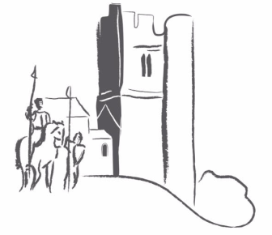
Balrothery Community Association

Current Consultation – Plans for Glebe Park Balrothery.

How to make an online submission.

Follow the link shown on www.balrothery.com
or alternatively using your internet browser

Go to www.fingal.ie

Click Planning & Buildings
Scroll down
Click ‘Development Plans & Consultations’
Scroll down
Click ‘Public Consultations’
Click ‘Current Consultations’
Click ‘Proposed Part VIII – Strategic Plan, Glebe Park, Balrothery.
Click ‘Make a Submission’
Follow instructions.

Note:- If you have not used the ‘consult fingal’ website portal before you will have to Register as a user (give username & password which can be used to login in future).

You can simply support the proposal in its current format or suggest changes or additions that you feel will better benefit the area. Opinion is subjective and now is the time to have your say.

The Deadline for submissions to be made is 28th June 2017.

